Tool for Easy Management of Files and Directories

In this project we are designing File Management tools which allow user to create directory, create file, write to file, read from file, delete file, rename file and get access count of each file.

To work with this system user has to signup and login to application and after login he can perform above mention operations.

SCREEN SHOTS

To run project double click on ‘run.bat’ file to get below screen

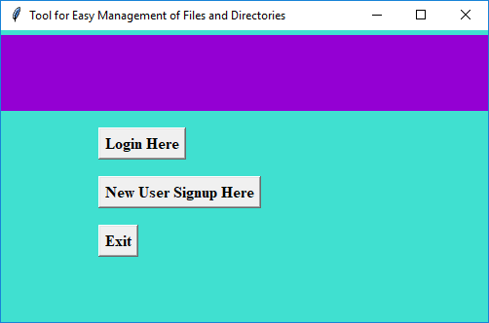

In above screen user has to click on ‘New User Signup Here’ button to signup with the application and get below output

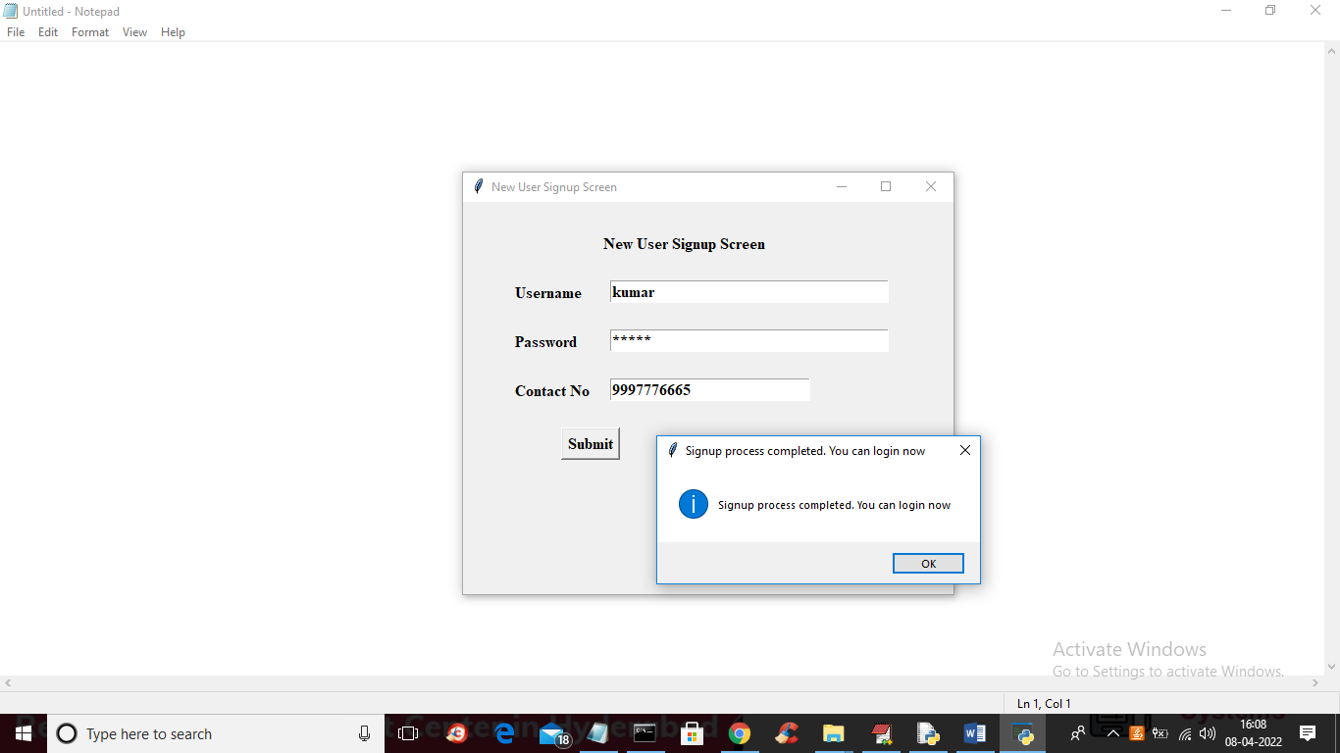

In above screen user has to enter signup details and press button to complete signup process and get below login screen

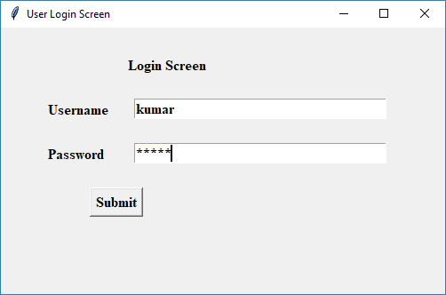

In above screen user is login and after login will get below screen

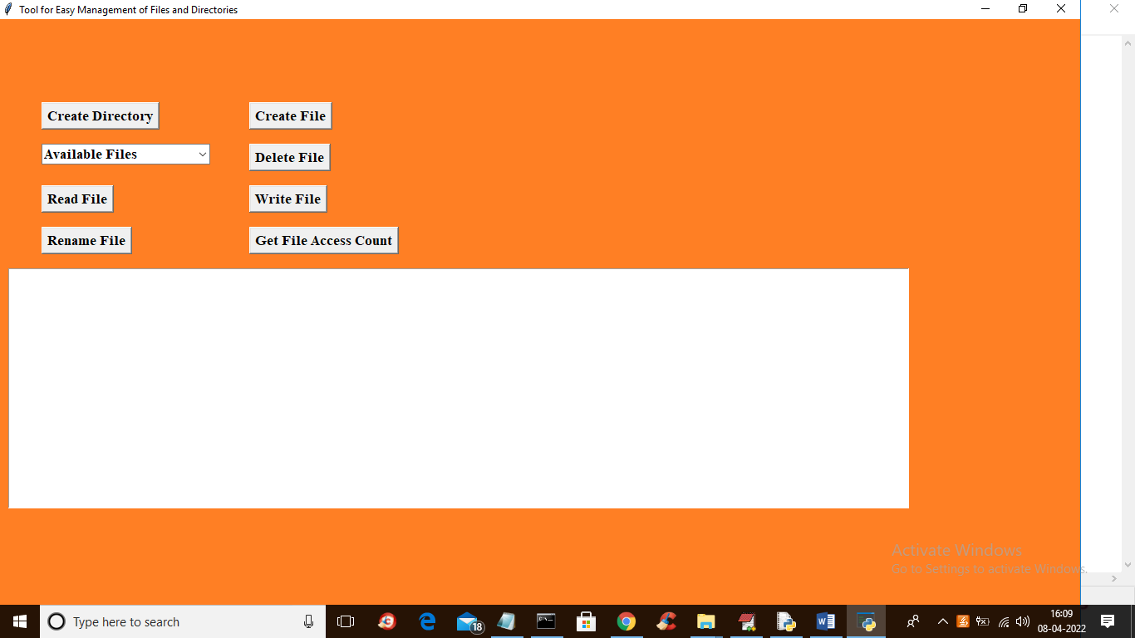

In above screen user can click on ‘Create Directory’ button to enter directory name and get below output

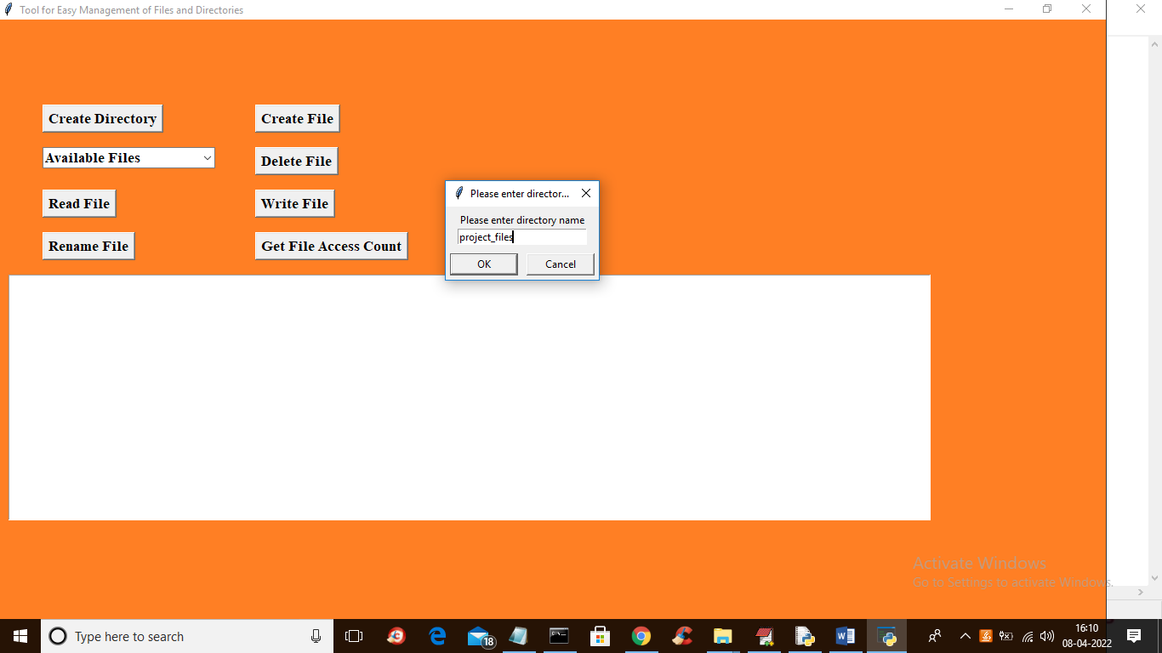

In above screen I entered directory name as ‘project_files’ and press OK to create directory and get below output

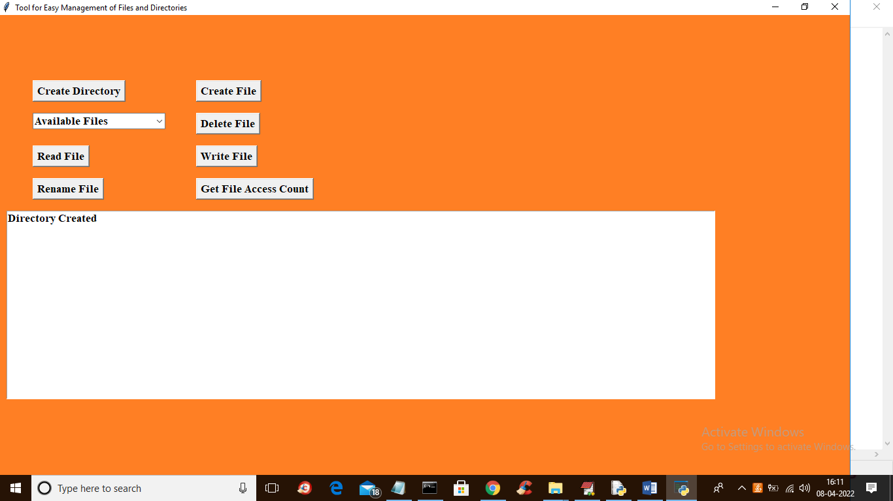

**In above screen in textarea we can see directory created and now click on ‘Create File’ button to create file**

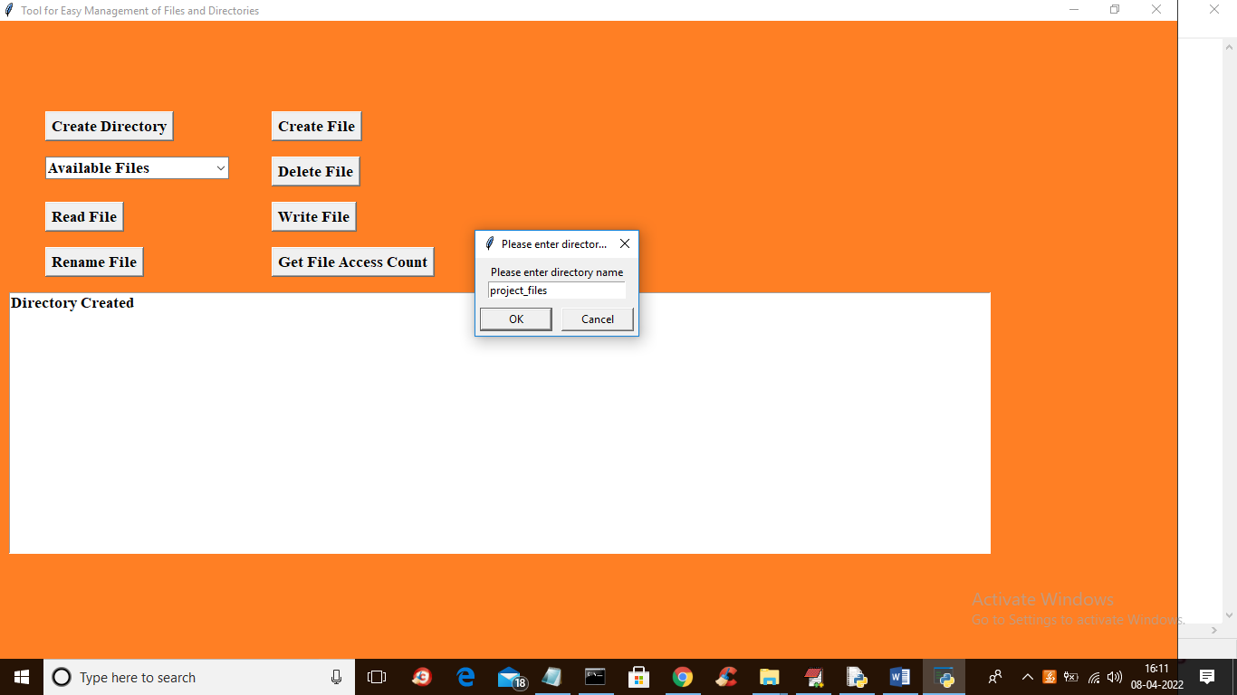

**In above screen enter directory name where file has to create and then enter file name like below screen**

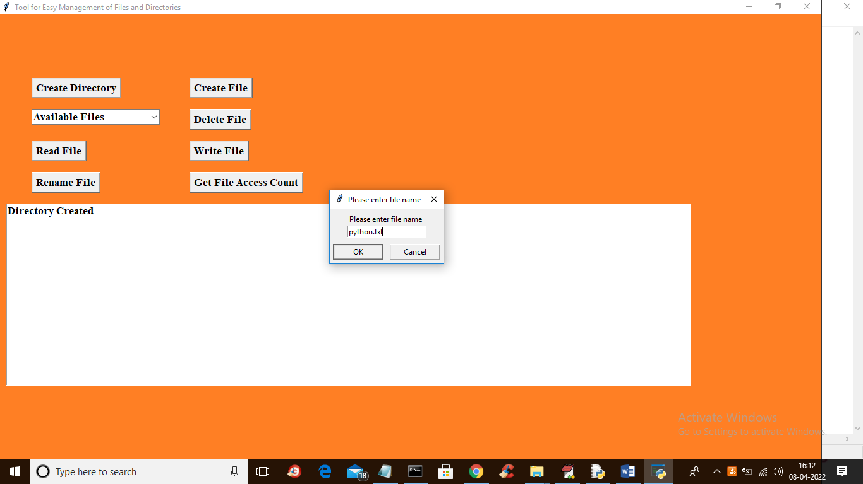

**In above screen I entered file name as ‘python.txt’ and press OK to get below output**

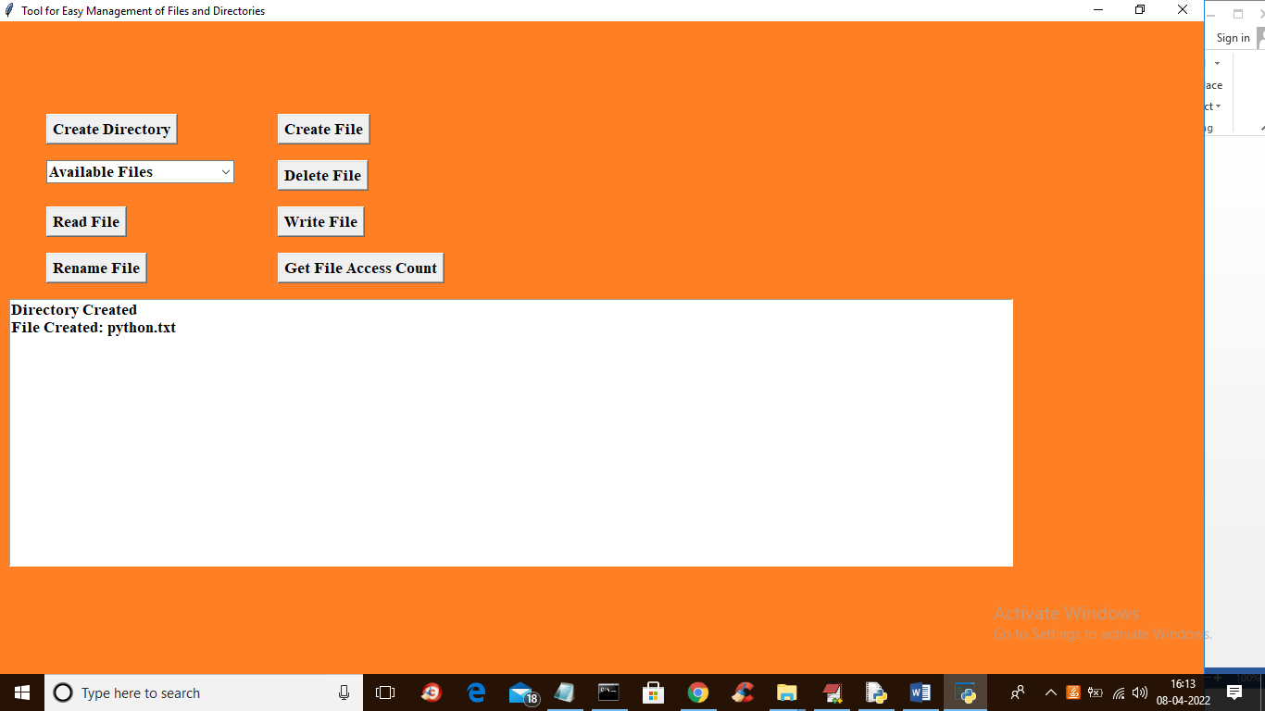

**In above screen we can see file is created and now see this file inside ‘files’ folder**

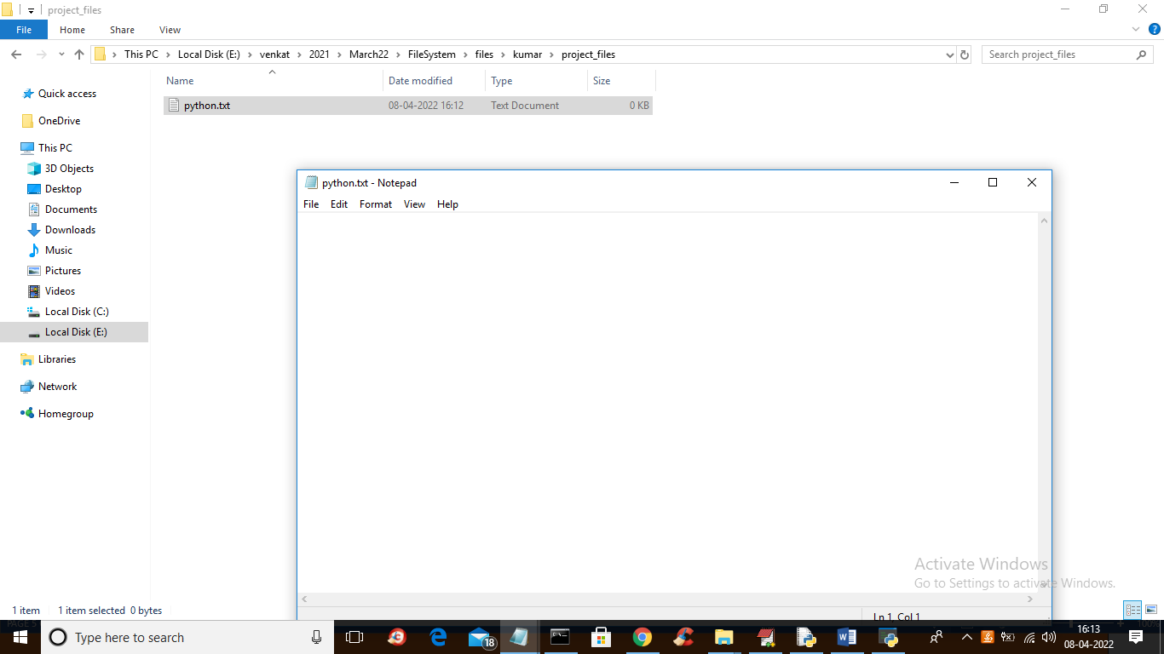

**In above screen inside ‘project_files’ we can see python.txt file is created and now file is empty and write some text to it by clicking on write file and select that file from drop down box**

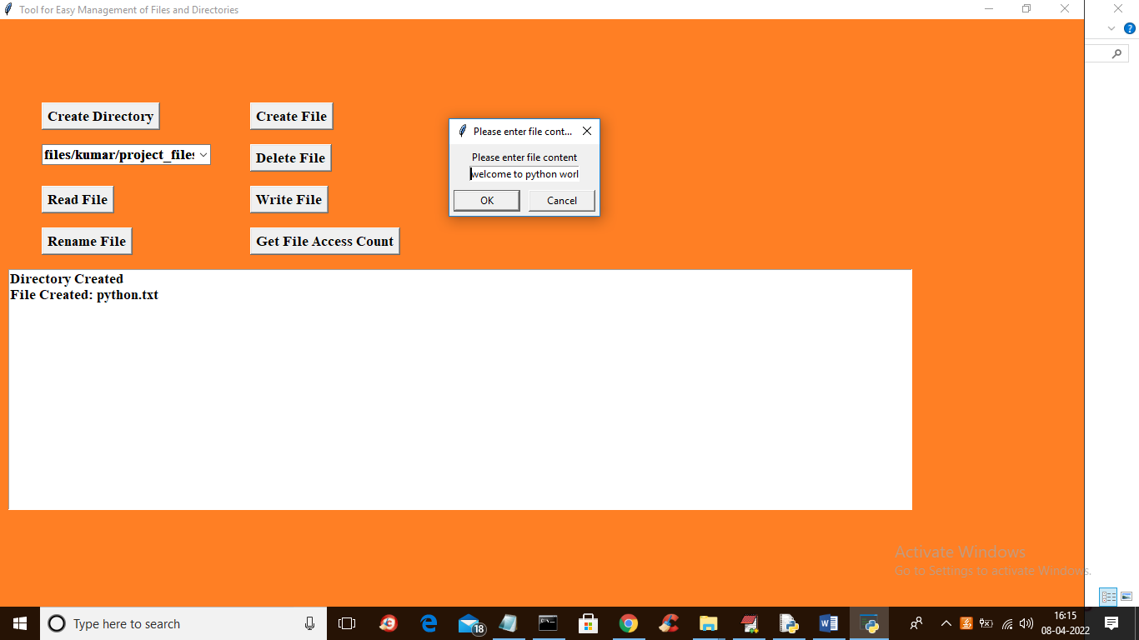

**In above screen from drop down I selected file and then enter some text content in dialog box and press OK to write that data to file**

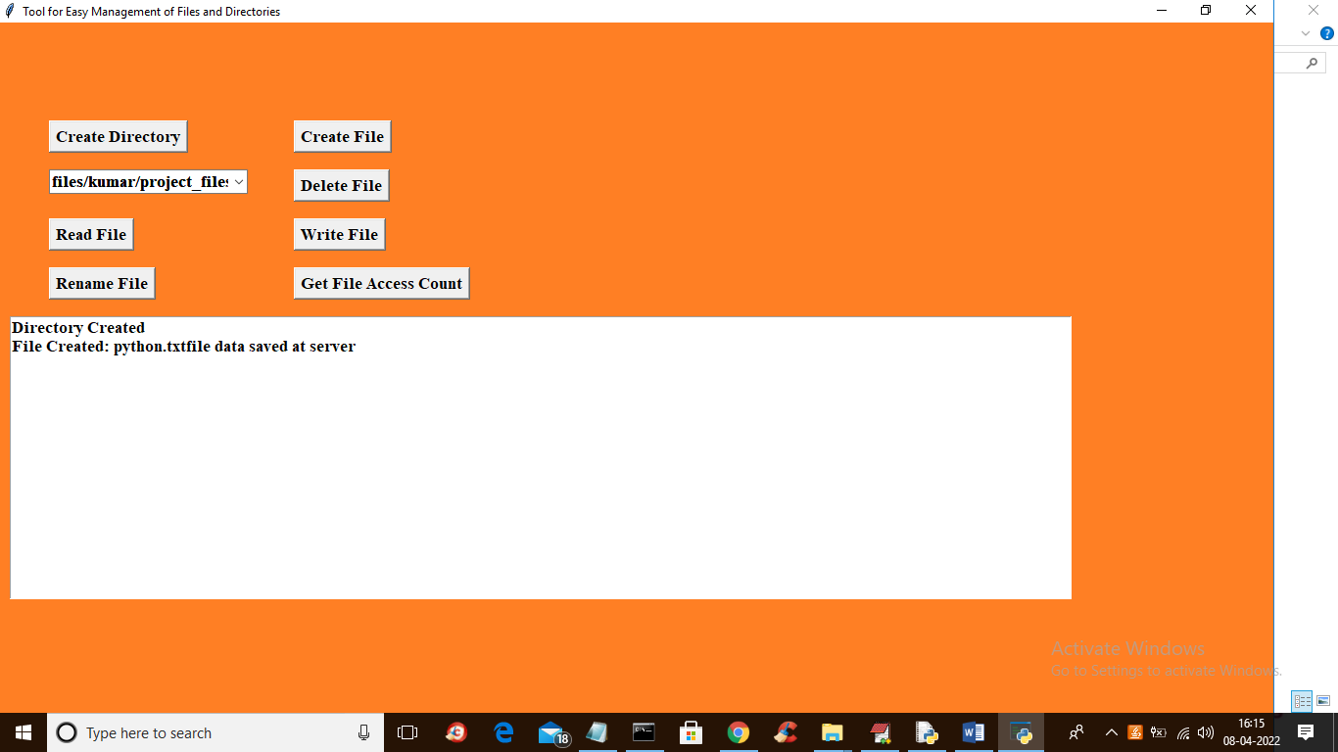

**In above screen we can see data saved at file server and in files directory also we can see that text**

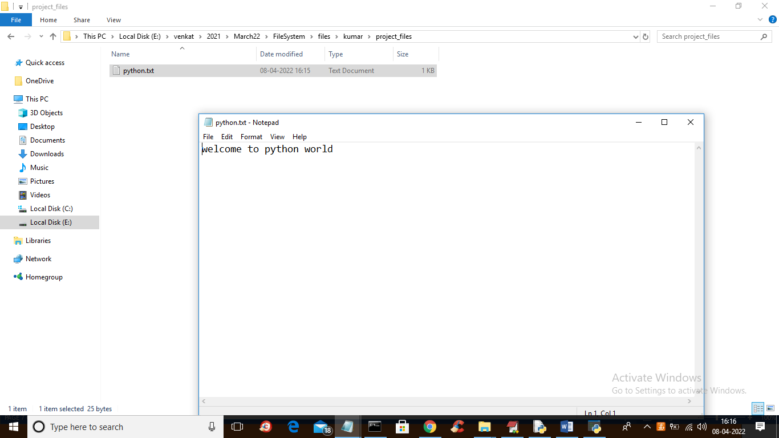

**In above screen we can see some text is written to file and we can read that data back by clicking on ‘Read File’ button**

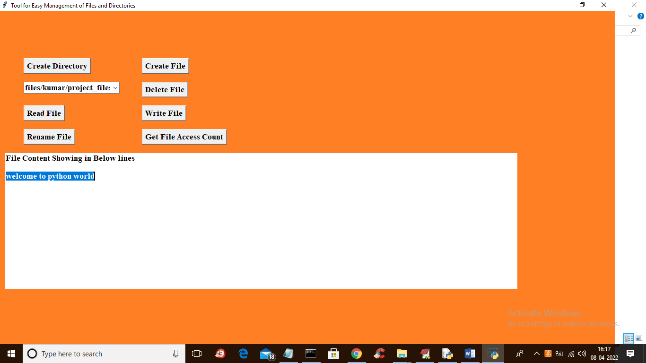

**In above screen we can see file is read and displaying to text area in blue colour and click on ‘Get File Access Count’ button to get access count of selected file**

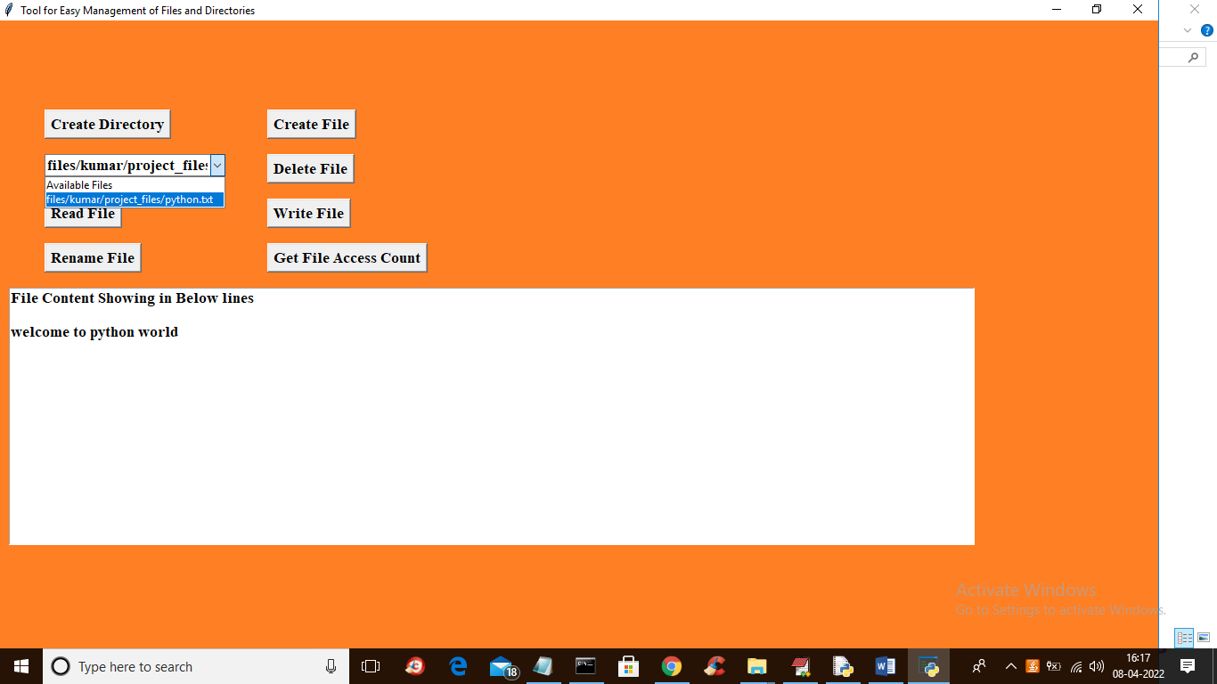

**In above screen from drop down box I selected one file and click on ‘Get File Access Count’ to get below output**

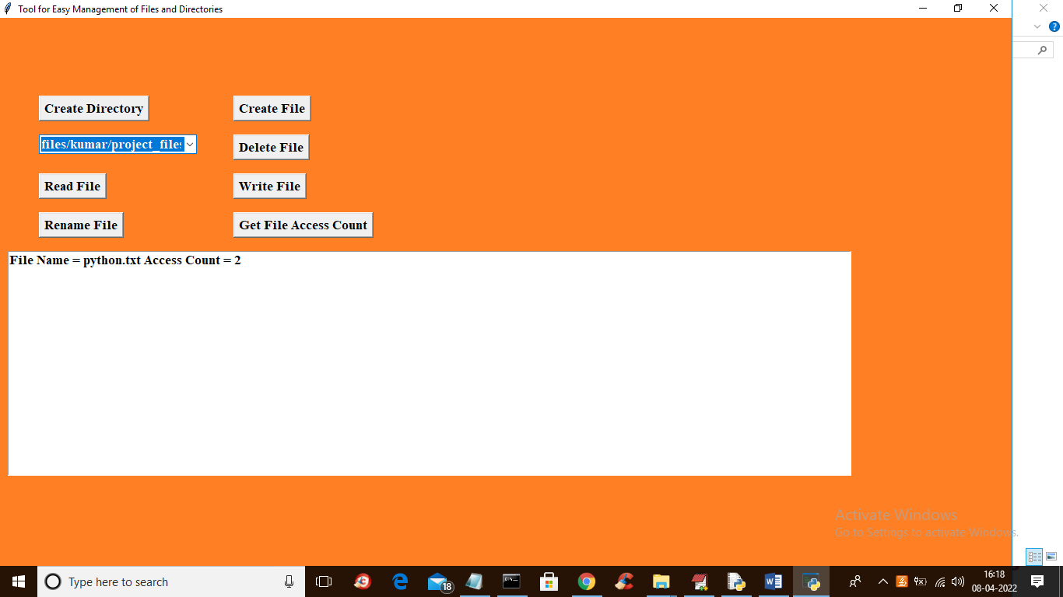

**In above screen we can see python.txt file access 2 times and similarly you can rename and delete file**